**COMSATS UNIVERSITY ISLAMABAD, LAHORE CAMPUS**



**EXERCISE NO 1**

|  |  |
| --- | --- |
| **NAME:** | HARIS ALI |
| **ROLL NO:** | FA24-BBA-068 |
| **COURSE:** | PROGRAMMING |
| **SUBMITTED TO:** | MA’AM MUFEEZA MANZOOR |

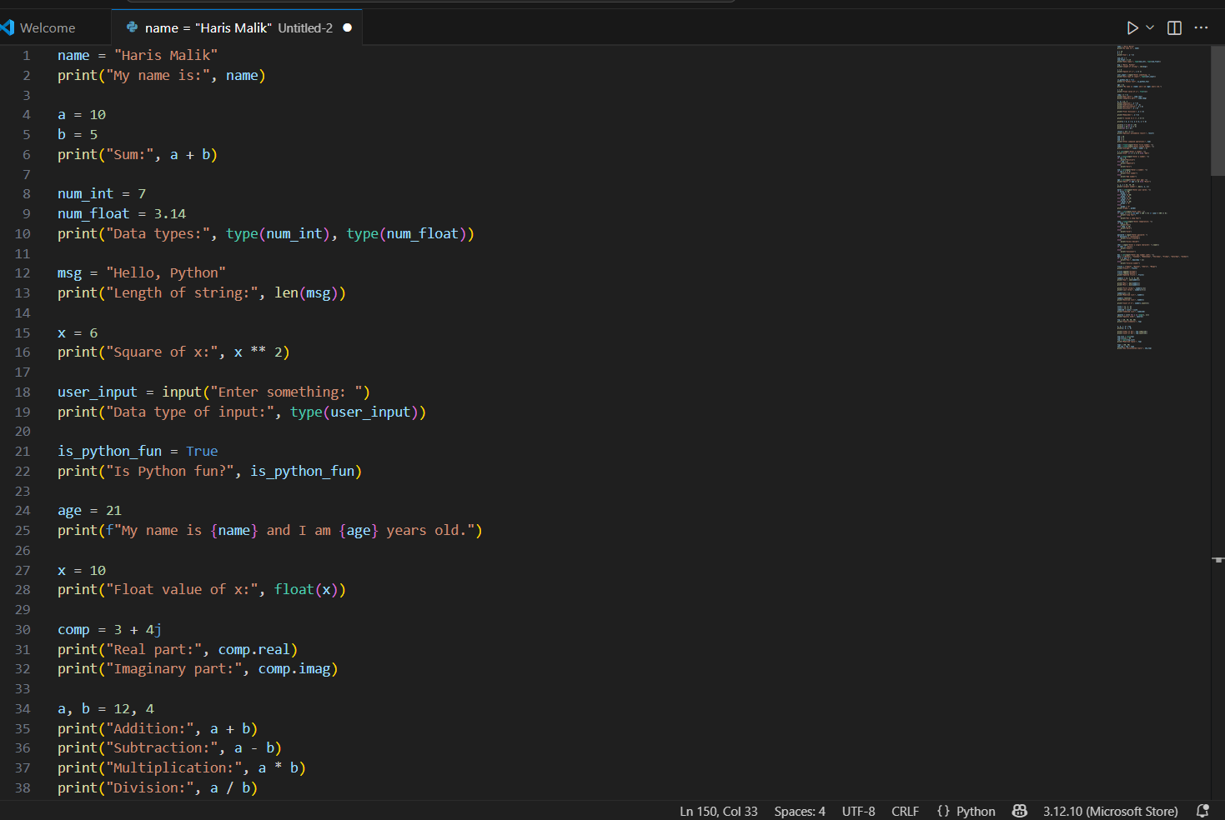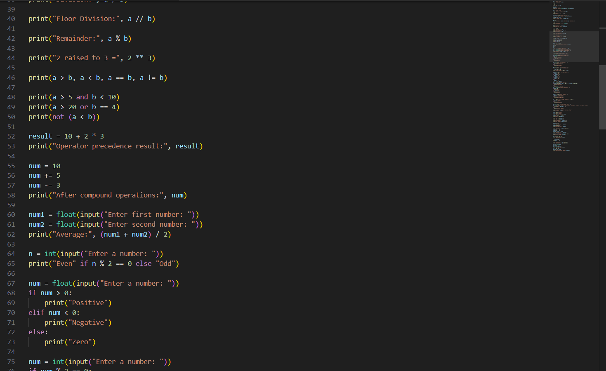**PROGRAMS**

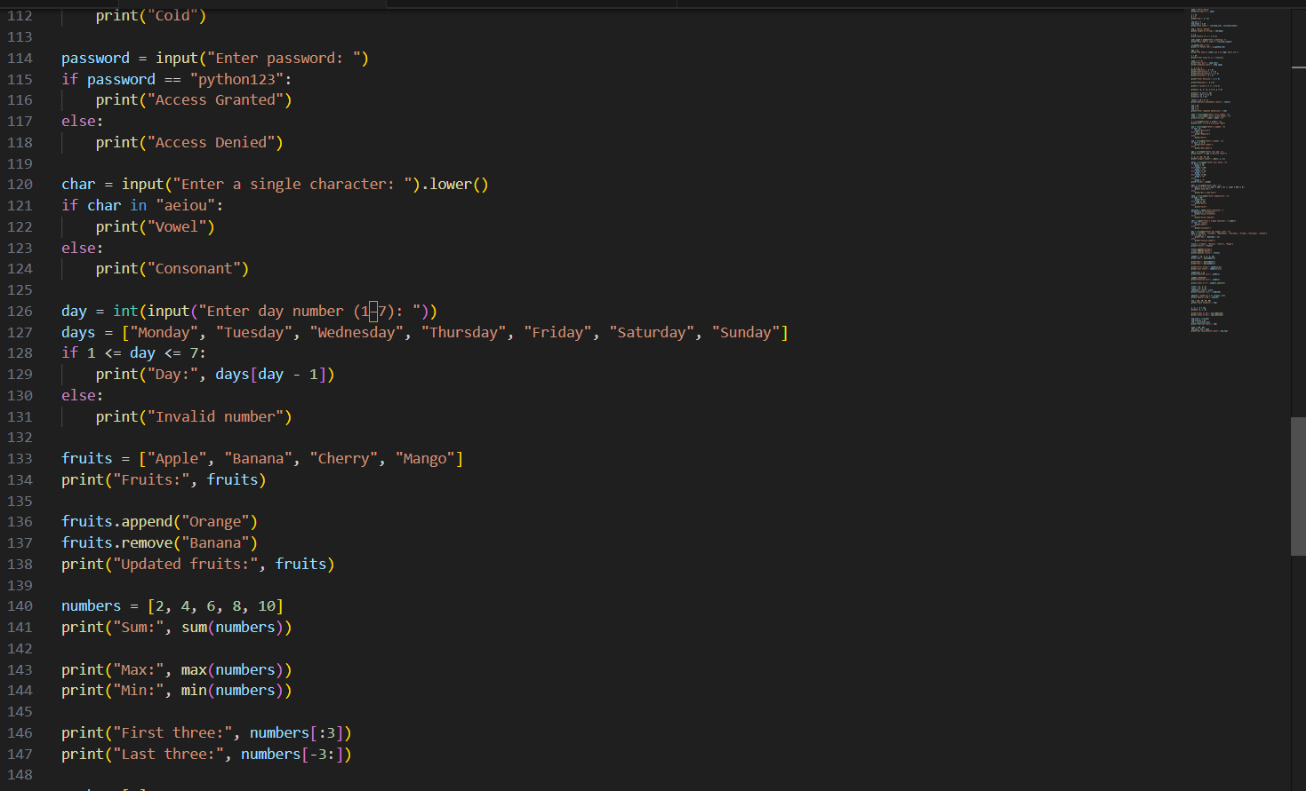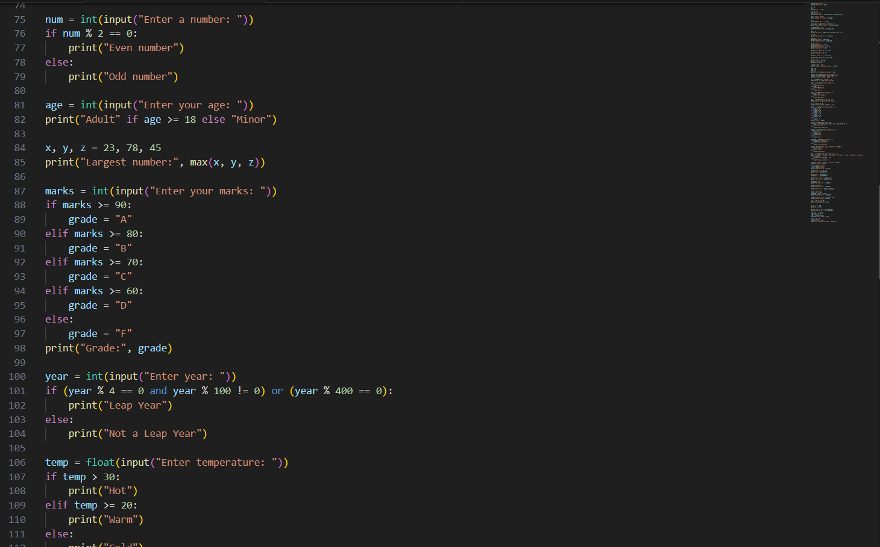

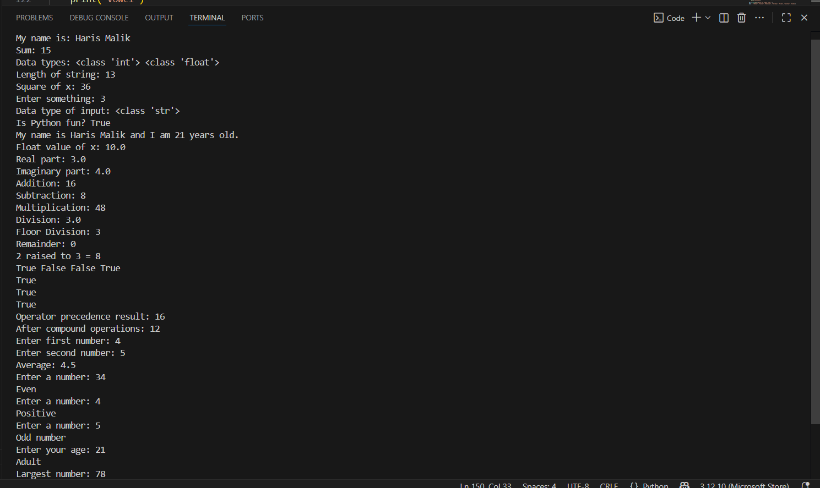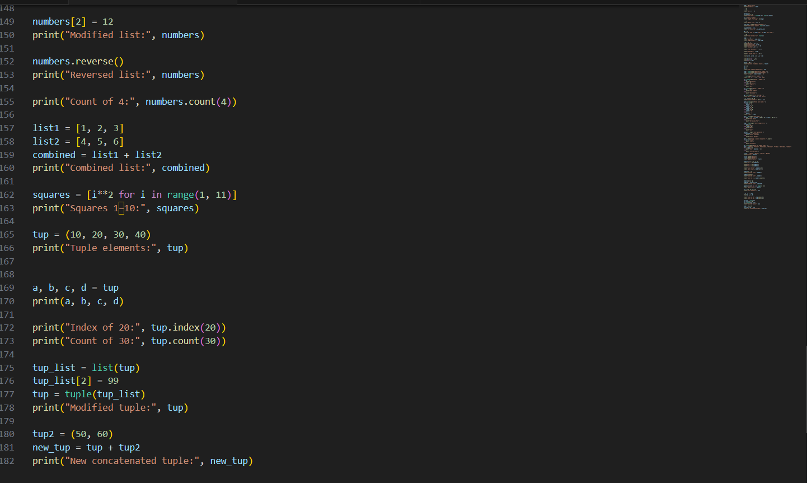**OUTPUT:**

